 | COMITÉ DE SUIVI INDIVIDUEL DU DOCTORANT
 | ÉCOLE DOCTORALE SCIENCES EXACTES ET LEURS APPLICATIONS (ED 211)

To improve readability, this document uses the masculine gender as a neutral gender throughout.

OBJECTIVES OF THE « COMITÉ DE SUIVI INDIVIDUEL DU DOCTORANT »:
In compliance with the amended Order of 25 May 2016, the « comité de suivi individuel du doctorant » (CSI) meets prior to each new registration until the completion of the doctorate.
The CSI ensures that the PhD runs well, based on the Doctoral Charter and the Individual Training Agreement. During the interview with the PhD student, his training conditions and research progress are assessed. The CSI is especially attentive to any form of conflict, discrimination, moral or sexual harassment or sexist behavior. If the CSI identifies any difficulties, the Chair of the CSI should inform the management of the laboratory and the doctoral school, which will take the required actions to address the situation of the PhD student and the progress of his doctoral studies (cf. point 5 of the Charter).
At the conclusion of the meeting, the CSI provides recommendations and submits a report to the director of the doctoral school, the PhD student, and the thesis supervisor(s). The purpose of these exchanges is to foster constructive dialogue.

ORGANISATION AND COMPOSITION OF THE CSI:
The CSI is organized at laboratory level. The PhD student is responsible for its logistical organization and must enter the CSI composition in ADUM.
- The CSI has at least three members:
  - At least one member who has expert knowledge of the discipline or a connection with the subject of the thesis.
  - Wherever possible, a member external to the university.
  - A non-expert member from outside the field of research of the thesis.
- The members of the CSI are: i) teachers-researchers, ii) researchers (academics or not, PhD holders), or iii) research engineers, holders of a PhD and authorized to supervise a thesis. Being certified to supervise research is not mandatory.
- At least one of the members is external to the laboratory, or the research team or the CNU section the thesis falls under.
- The CSI members do not take part in supervising the PhD student’s work
(the thesis supervisor, the co-supervisor where applicable, and more generally speaking, anyone taking part in supervising the thesis, cannot be member of the committee).
- The ED makes sure the PhD student is consulted as regards the composition of his CSI before the meeting.
- If possible, the members of the CSI remain the same throughout the thesis.
- The CSI members may attend the CSI meeting remotely.
- The committee members may subsequently be on the thesis jury but cannot be appointed as examiners due to the role they play in evaluating the thesis in the CSI meetings.

THE FUNCTIONNING OF THE CSI:
At the latest one week before the committee meeting, the PhD student passes on to the members a concise report (maximum one page) on the progress of his work, a “training course attendance sheet” and a “skills self-assessment approach” document taken from ADUM. The PhD student carrying out the thesis under a “cotutelle” framework must also provide a summary (place and dates) of his mobilities.
The CSI meeting takes place in three stages:
- Step 1 - presentation of work progress and discussions: the PhD student talks about the progress made on his thesis work, the training courses taken throughout the year, and presents his project for the following year (project schedule / planned training courses) to the committee and the thesis supervisor(s); this presentation is followed by discussions with all members present.
- Step 2 - interview of the PhD student without the thesis supervisor(s);
- Step 3 - interview with the thesis supervisor(s) without the PhD student.
The CSI members draw up a report of the meeting, based on the document below.
The PhD student and the thesis supervisor(s) read the report and can make comments. They sign the document, and the PhD student submits it on ADUM so he can then re-enroll.

COMITÉ DE SUIVI INDIVIDUEL DU DOCTORANT
ÉCOLE DOCTORALE SCIENCES EXACTES ET LEURS APPLICATIONS (ED 211)

Last name and first name of the PhD student
Thesis supervisor (and co-supervisor):

Type of thesis contract: full-time ◻ part-time ◻

“Cotutelle”: YES ◻ NO ◻

If YES, specify the partner university :
Current thesis year: | Need a derogation to re-enroll*: YES ◻ NO ◻  * >3 years for a full-time thesis, >6 years for a part-time thesis
Date of the CSI:

COMPOSITION OF THE CSI  (cf. page 1) | LAST NAME/FIRST NAME | LABORATORY and CNU SECTION | SIGNATURE
Chairman of the CSI
Member 2
Member 3
Other member

PLEASE CONFIRM THE THESIS SPECIALIZATION FOR RE-ENROLLMENT IN 2025/2026.
See ATTACHED APPENDIX

REVIEW OF THE PROGRESS OF THE RESEARCH PROJECT
CRITERIA |  | COMMENTS / ASSESSMENT DETAILS
1 | Knowledge of the subject
2 | Ability to summarize
3 | Progress of the project vs. the schedule in the Individual Training Agreement
4 | Oral presentations  (International conferences / posters / workshops)
5 | Publications
6 | Integration into the research team

PROGRESS OF THE PROJECT AND GENERAL ASSESSMENT:

OBJECTIVES FOR THE NEXT YEAR:

REVIEW OF THE TRAINING PLAN AND THE TRAINING CARRIED OUT TO ACQUIRE THE SKILLS REQUIRED TO OBTAIN THE TITLE OF DOCTOR (Order of February 2019)
 | CRITERIA |  | COMMENTS / ASSESSMENT DETAILS
1 | Progress on the training plan?  % of required skills acquired?  Skills still to be acquired?  (see "Skills blocks" table below)
2 | Language certification? (TOIEC, CAMBRIDGE…)
3 | Changes to the training plan?
COTUTELLE THESIS
REVIEW OF MOBILITY UNDERTAKEN AS PART OF THE “COTUTELLE” PROGRAMME
 | PLACE |  |  |  | DATES
1
2
3
OPINION OF THE COMMITTEE
(Report to be attached to the re-registration form)
☐ FAVORABLE  to the continuation of the thesis |  | ☐ FAVORABLE  with thesis defense before (date): |  |  |  | ☐ UNFAVORABLE  to the continuation of the thesis
The PhD student certifies that he has read the opinion of the CSI.
Comments: (below or on a separate sheet)

Signature of the PhD student:

Comments of the thesis supervisor(s):

Signature of the thesis supervisor(s)

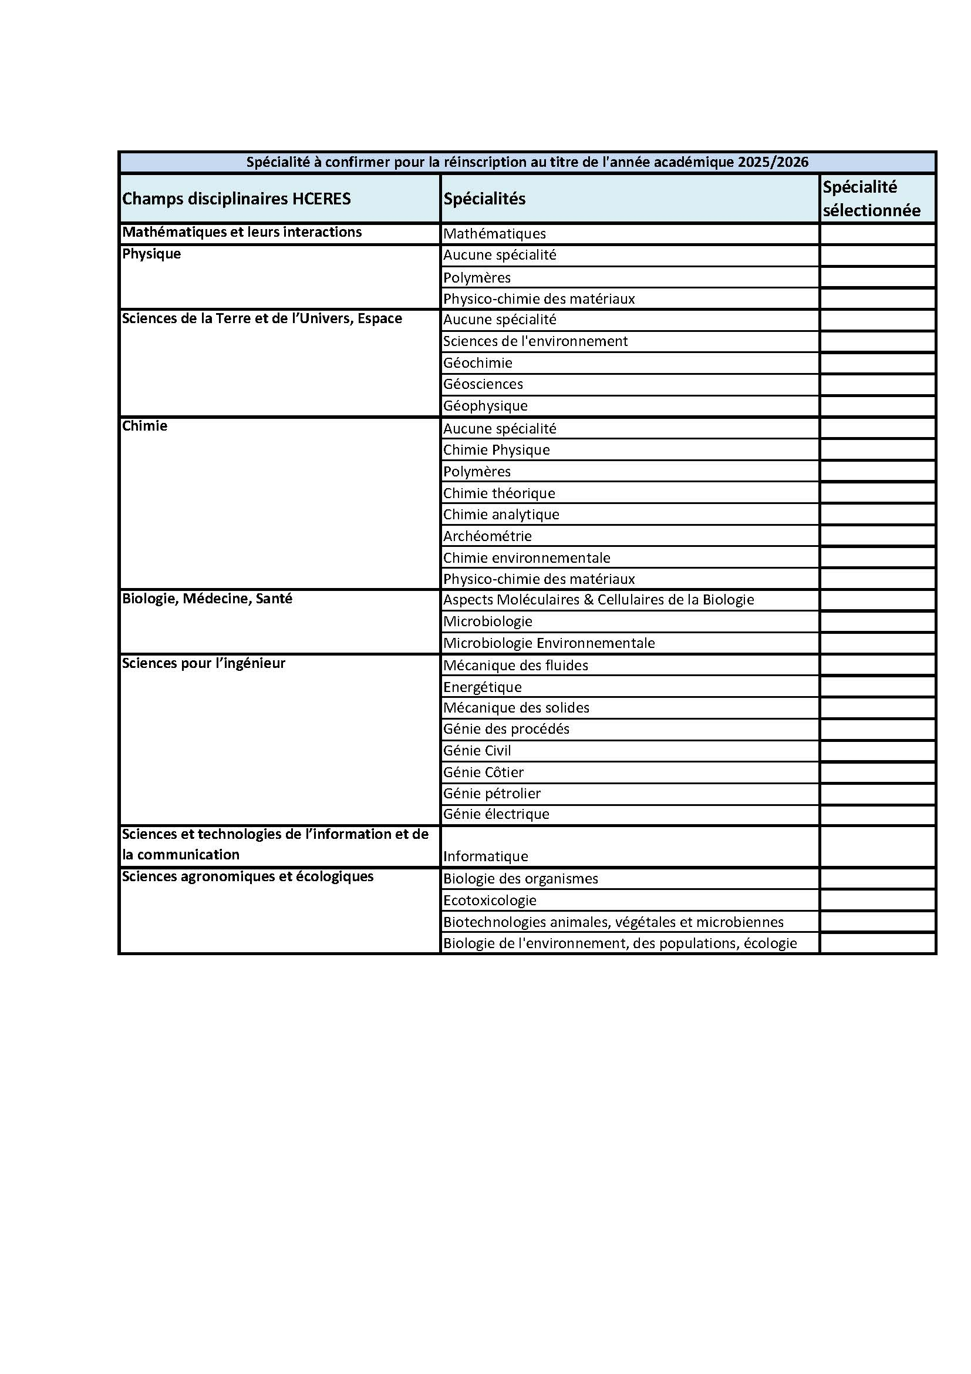
TABLE PROVIDED FOR INFORMATION TO CSI MEMBERS

BLOCKS OF SKILLS and SUB-SKILLS
Block 1:  Design and development of research and development, studies and forecasts | To have both general and specific scientific expertise in a given field of research and work
 | To appraise the state and limits of knowledge within a given sector of activity, at local, national and international levels
 | To identify and solve complex and new problems involving a number of fields, using the most advanced knowledge and skills available
 | To identify the potential for conceptual breakthroughs and design innovation paths for a professional sector
 | To make innovative contributions as part of high-level exchanges and in international contexts
 | To adapt constantly to the needs of research and innovation within a professional sector
Block 2:  Implementing a research and development, study and forecasting approach | To apply research methods and tools in relation to innovation
 | To apply the principles, tools and procedures for evaluating the costs and financing of an innovation or R&D project.
 | To guarantee the validity of the work as well as its ethics and confidentiality by implementing appropriate control systems
 | To manage the time constraints of research, innovation and R&D activities
 | To implement the commitment, risk management and autonomy required to complete an R&D, research or innovation project.
Block 3:  Developing and transferring the results of R&D, studies and forecasts | To implement transfer issues with a view to exploiting and adding value to results or products in economic or social sectors
 | To comply with intellectual and industrial property rules relating to a sector
 | To respect the principles of deontology and ethics in relation to the integrity of the work and its potential impact
 | To implement all the publication mechanisms at international level to promote new knowledge and know-how
 | To use open data communication techniques to promote initiatives and results
Block 4:  International science and technology monitoring | To acquire, synthesize and analyze cutting-edge scientific and technological data and information on an international scale
Block 4:  International science and technology monitoring | To understand, step back and take a critical look at all the cutting-edge information available
Block 4:  International science and technology monitoring | To go beyond the frontiers of available data and knowledge by cross-referencing with different fields of knowledge or other professional sectors
Block 4:  International science and technology monitoring | To develop international scientific and professional cooperation networks
Block 4:  International science and technology monitoring | To have the curiosity, adaptability and openness needed to develop and maintain a high level of general and international culture
Block 5:  Training and dissemination of scientific and technical culture | To report on and communicate scientific and technological work to different audiences and publications in several languages, both orally and in writing
 | To teach and train diverse audiences in advanced concepts, tools and methods
 | To be able to adapt to a varied audience in order to communicate and promote cutting-edge concepts and approaches
Block 6:  Management of teams dedicated to research and development, studies and forecasting activities | To lead and coordinate a team in complex or interdisciplinary tasks
 | To identify skills that are lacking within a team and to participate in recruiting or soliciting service providers
 | To develop the steps needed to foster an entrepreneurial spirit within a team
 | To identify the key resources for a team and prepare for changes in terms of training and personal development
 | To assess the work of individuals and the team in relation to projects and objectives

To re-register for the second year, the PhD student must also present its training agreement.

